Learning Opportunities:
DAIRY Internship
Year Around
Work with our micro raw milk dairy providing local fresh milk from our grass fed cows on our certified organic land. We take a break Jan and Feb from milking but we maintain the herd's needs.
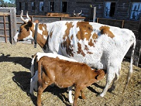
2016 VEGETABLE SEED INTERNSHIP
Year round internship includes Intensive horticultural production on 4 acres with a focus on vegetable seed production integrated into a CSA/Market vegetable garden. Activities include field preparation, cultivation growing, harvesting, threshing, cleaning, and packing seed for sale, and selling vegetables at a local farmer’s markets. Integrated with this is a small cow herd and raw milk dairy that provides fertility through compost and intensive rotational grazing. Studies includes Biodynamic® farming and gardening texts, with a special emphasis in building agricultural communities and Threefolding concepts. We prefer interns staying 2 years to gain the full experience and training in seed growing.
2016 Autumn SEED Internship
3-4 month: September-December
Harvesting in September, cleaning and testing seed and learning about seed distribution throughout September-December. While you will learn much more of the context of seed if you come in the early spring, we offer the autumn internship for experienced farmers or gardeners who want to supplement their other agricultural experiences.
Interested applicants, please send short bio, resume, reasons for your interest and goals regarding agriculture to: bcorymb@gmail.com and call to let us know that you have sent it. 308- 631-5877
Transition Opportunity!
For Meadowlark Hearth

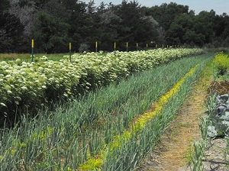
A 520 acre Organic/Biodynamic® certified family farm seeking long-term operator/entrepreneur(s) to transition the farm in Scottsbluff, NE. Fully running national vegetable seed business with a year-round vegetable CSA, a grass-fed beef/milk herd and rangeland for grazing. Vegetable seed grown includes cabbage, onion, carrots, beets, parsnips, annual herbs, peas, lettuce, tomatoes, peppers, eggplant, melon, cucumber and squash. Potential for Grain crops

As elder farmers in their 60’s, current owners are professional seed growers with decades of experience. This is a unique opportunity to help build a community practicing Biodynamic® principles in a whole farm setting integrating plants and animals. They are committed to reintegrate Organic/Biodynamic® seed growing into everyday agriculture on diverse, sustainable, human-scale farms, and developing a welcoming and nourishing farm environment that includes people from many walks of life, ages and abilities to work together. They are looking for compatible and professional agriculturalists interested in building community.

An outstanding opportunity for the right combination of farmers and community minded agriculturalists to access land and equipment without the burden of debt.

Applicants from ages 20-40’s need to have experience in professional organic farming, interest in pursuing Biodynamic® methods, in building community on the farm, and a willingness to work with older farmers.
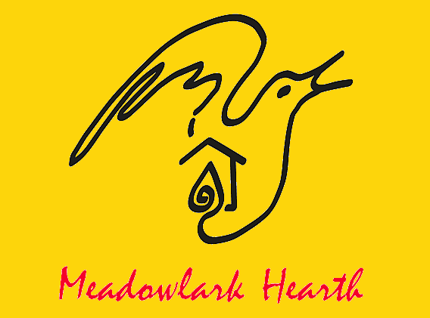
Seed Production
Arising out of a
Whole Farm
www.meadowlarkhearth.org
And
Living Environment Foundation
501c3
Cultivating Soil, Seed and Community
through ecological stewardship
and Biodynamic® agriculture
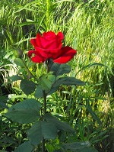
Beth and Nathan Corymb
120024 Everett Drive,
Scottsbluff, NE 69361
308-631-5877
bcorymb@gmail.com

About Meadowlark Hearth

Sitting at nearly 4,000 feet altitude,
Meadowlark Hearth spreads out over 520 acres in western Nebraska. The site is good for seed production, offering a warm, dry climate and a high water table on the Ogallala aquifer with 48 acres of irrigated crop ground and 16 inches average annual rainfall. Vegetable seed grown includes cabbage, onion, carrots, beets, parsnips turnips, annual herbs, peas, lettuce, tomatoes, peppers, eggplant, melon, cucumber and maxima, moschata and pepo squash.

In 1994, Nathan and Beth founded the Turtle Tree Biodynamic® Seed Initiative (in Minnesota) to distribute Biodynamic® seed in the US. In 1998 they brought Turtle Tree to Camphill Village in Copake, NY, and combined it with social therapeutic work for special needs adults gifting it to Camphill Village USA. From Nebraska, Corymbs continue to work with a network of Biodynamic® growers. They are committed to reintegrate seed growing into everyday agriculture on diverse, sustainable, human-scale farms, and developing a welcoming and nourishing farm environment that included people from many walks of life, ages and abilities.

These aspirations have been continued, as the Corymbs took up farming their family homestead in 2010 and the land is now Organic and Demeter Certified Biodynamic® for seed growing. They are working to develop a demonstration Biodynamic® farm combining seed growing, Community Supported Agriculture, Biodynamic® training and social work. They produce seed, vegetables and heirloom livestock.

Corymbs are also developing a nature preserve along the North Platte River to demonstrate how wild lands work in concert with farming. As well as being a seedsman, Nathan Corymb is also a master naturalist and spends at least one day per week, communing with nature in the Wild Cat Hills near the farm. Beth studies how music and agriculture relate to each other throughout the seasons.

Vegetable Seed Production
Workshop Series
Integrated into
Wholeness of Farming

A 2016 workshop series dedicated to professional farmers and gardeners seeking more information and practice on Seed Production as part of a diversified on-farm income.
Email to RSVP and receive the schedules and lodging possibilities.
Registration is free to the public. Limited on-site camping possible.
Biennial Seed Stock & Garden Planning
Apr. 9-10 /// Meadowlark Hearth; Scottsbluff, NE
Kick off the season with hands-on intensive focused on care and rearing of biennial seed crops; carrots, brassicas, beets, etc. We'll cover basics about over-wintering whole plants and roots in a harsh climate, basic crop planning and isolation/population needs for seed growing.
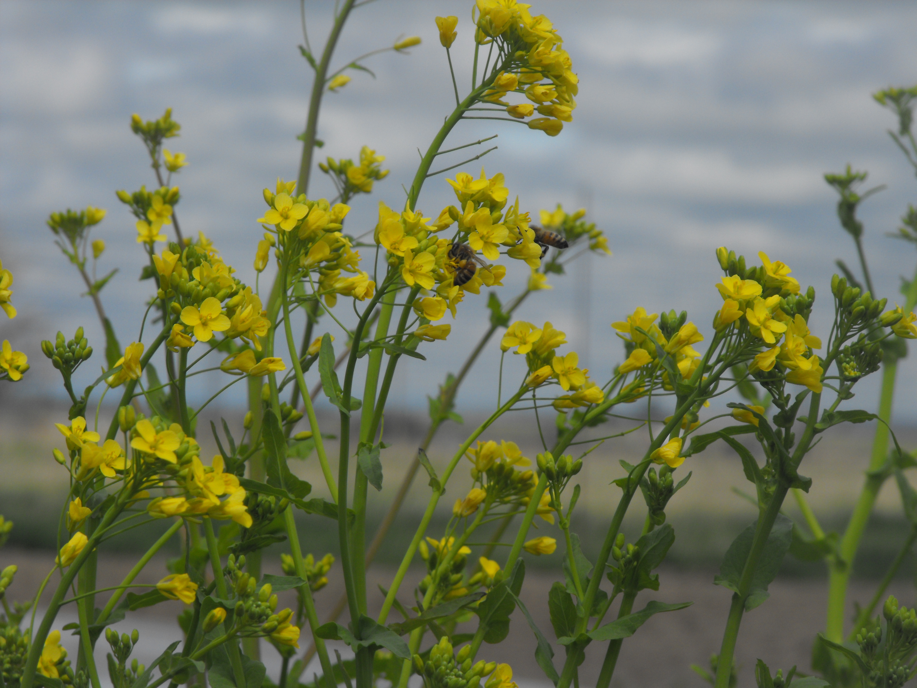
Blooming Tours & Class
July 9-10 /// Meadowlark Hearth; Scottsbluff,NE
Visit Meadowlark Hearth fields and take in the latest blooms of our annual and biennial seed crops! Topics to be covered include pollination, isolation, and population size considerations. You'll be able see how trellising works for certain crops and visualize how Seed Work will integrate into your farm or garden.

3rd Annual Labor Day SEED FEST
Sept. 4-5 /// Meadowlark Hearth; Scottsbluff, NE
Welcome to our Celebration of Seed! An annual event where friends, family and local community come together to learn and share in our seed saving traditions. Always a hoot with a bean stomp and other fun threshing activities. This will be an exciting and welcoming atmosphere for beginner and professional farmers alike. Come early Sunday for Seed technique classes and stay through Monday for the fun threshing.

Seed Production for Professional Farmers
Oct 1-2 /// Meadowlark Hearth; Scottsbluff,NE
This course is designed for experienced growers and farmers. We'll focus on seed production techniques, learn how to initiate & carry out seed contracts and figure out how to weave Seed onto a working farm. Come prepared with questions and expect many hands-on activities. You'll have the chance to see various small and mid-scale tools.
Workshops sponsored in part by Specialty Crops Grant
to Living Environment Foundation
from the NE Dept. of Agriculture

